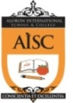
In the name of Allah, the most Merciful, the most Kind
ALORON INTERNATIONAL SCHOOL & COLLEGE
5/1, Shah Ali Bag, Mirpur-1, Dhaka-1216 Tel: 02 8035013, 02 9000574

Notice

Wednesday 03 February, 2016

Dear Parents,
Assalamu Alaikum.

We are delighted to invite you to the Teachers’-Parents’ Meeting of Step II English Version and Bangla Version and to become involved to make this school an even better place for all the children. You are requested to present in the meeting on time. Your attendance in the programme will be treated as your child’s regular attendance.

Date: Saturday 06 February, 2016 Time: 10 am to 11.35 am
Place: Ground Floor, AISC

Thank you for your cooperation.
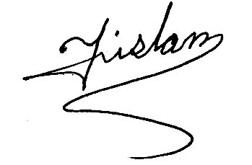
Principal
AISC

